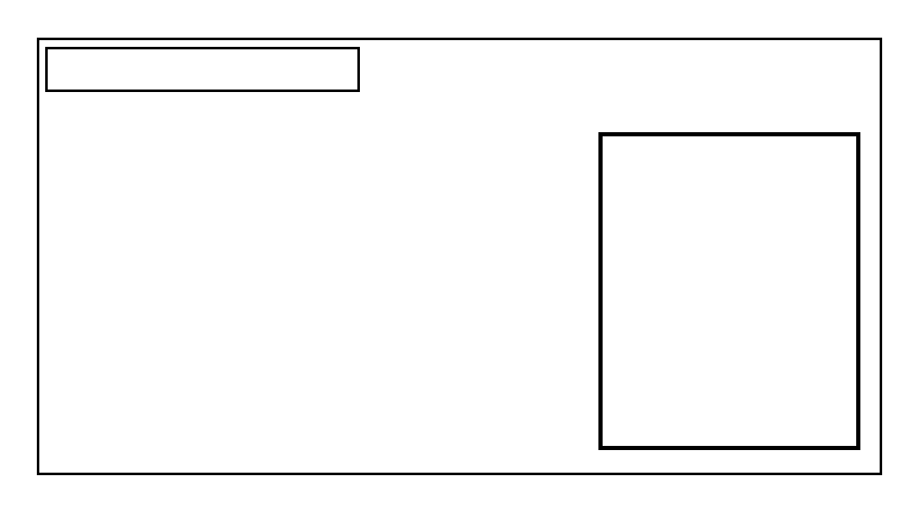

NAME : MOHAN KUMAR

FATHER’S NAME : ANIKET KUMAR

HOUSE NO. : 48

AGE : 28 SEX : MALE

XYZ1234567890

1